**Project Proposal**

Cryptocurrency Database

A Relational Database (with the possibility of adding a non-relational database as well) on cryptocurrency data that allows for understanding the cryptocurrency market data on a deeper level. The ER Diagram below shows a more detailed description of the database and the content:

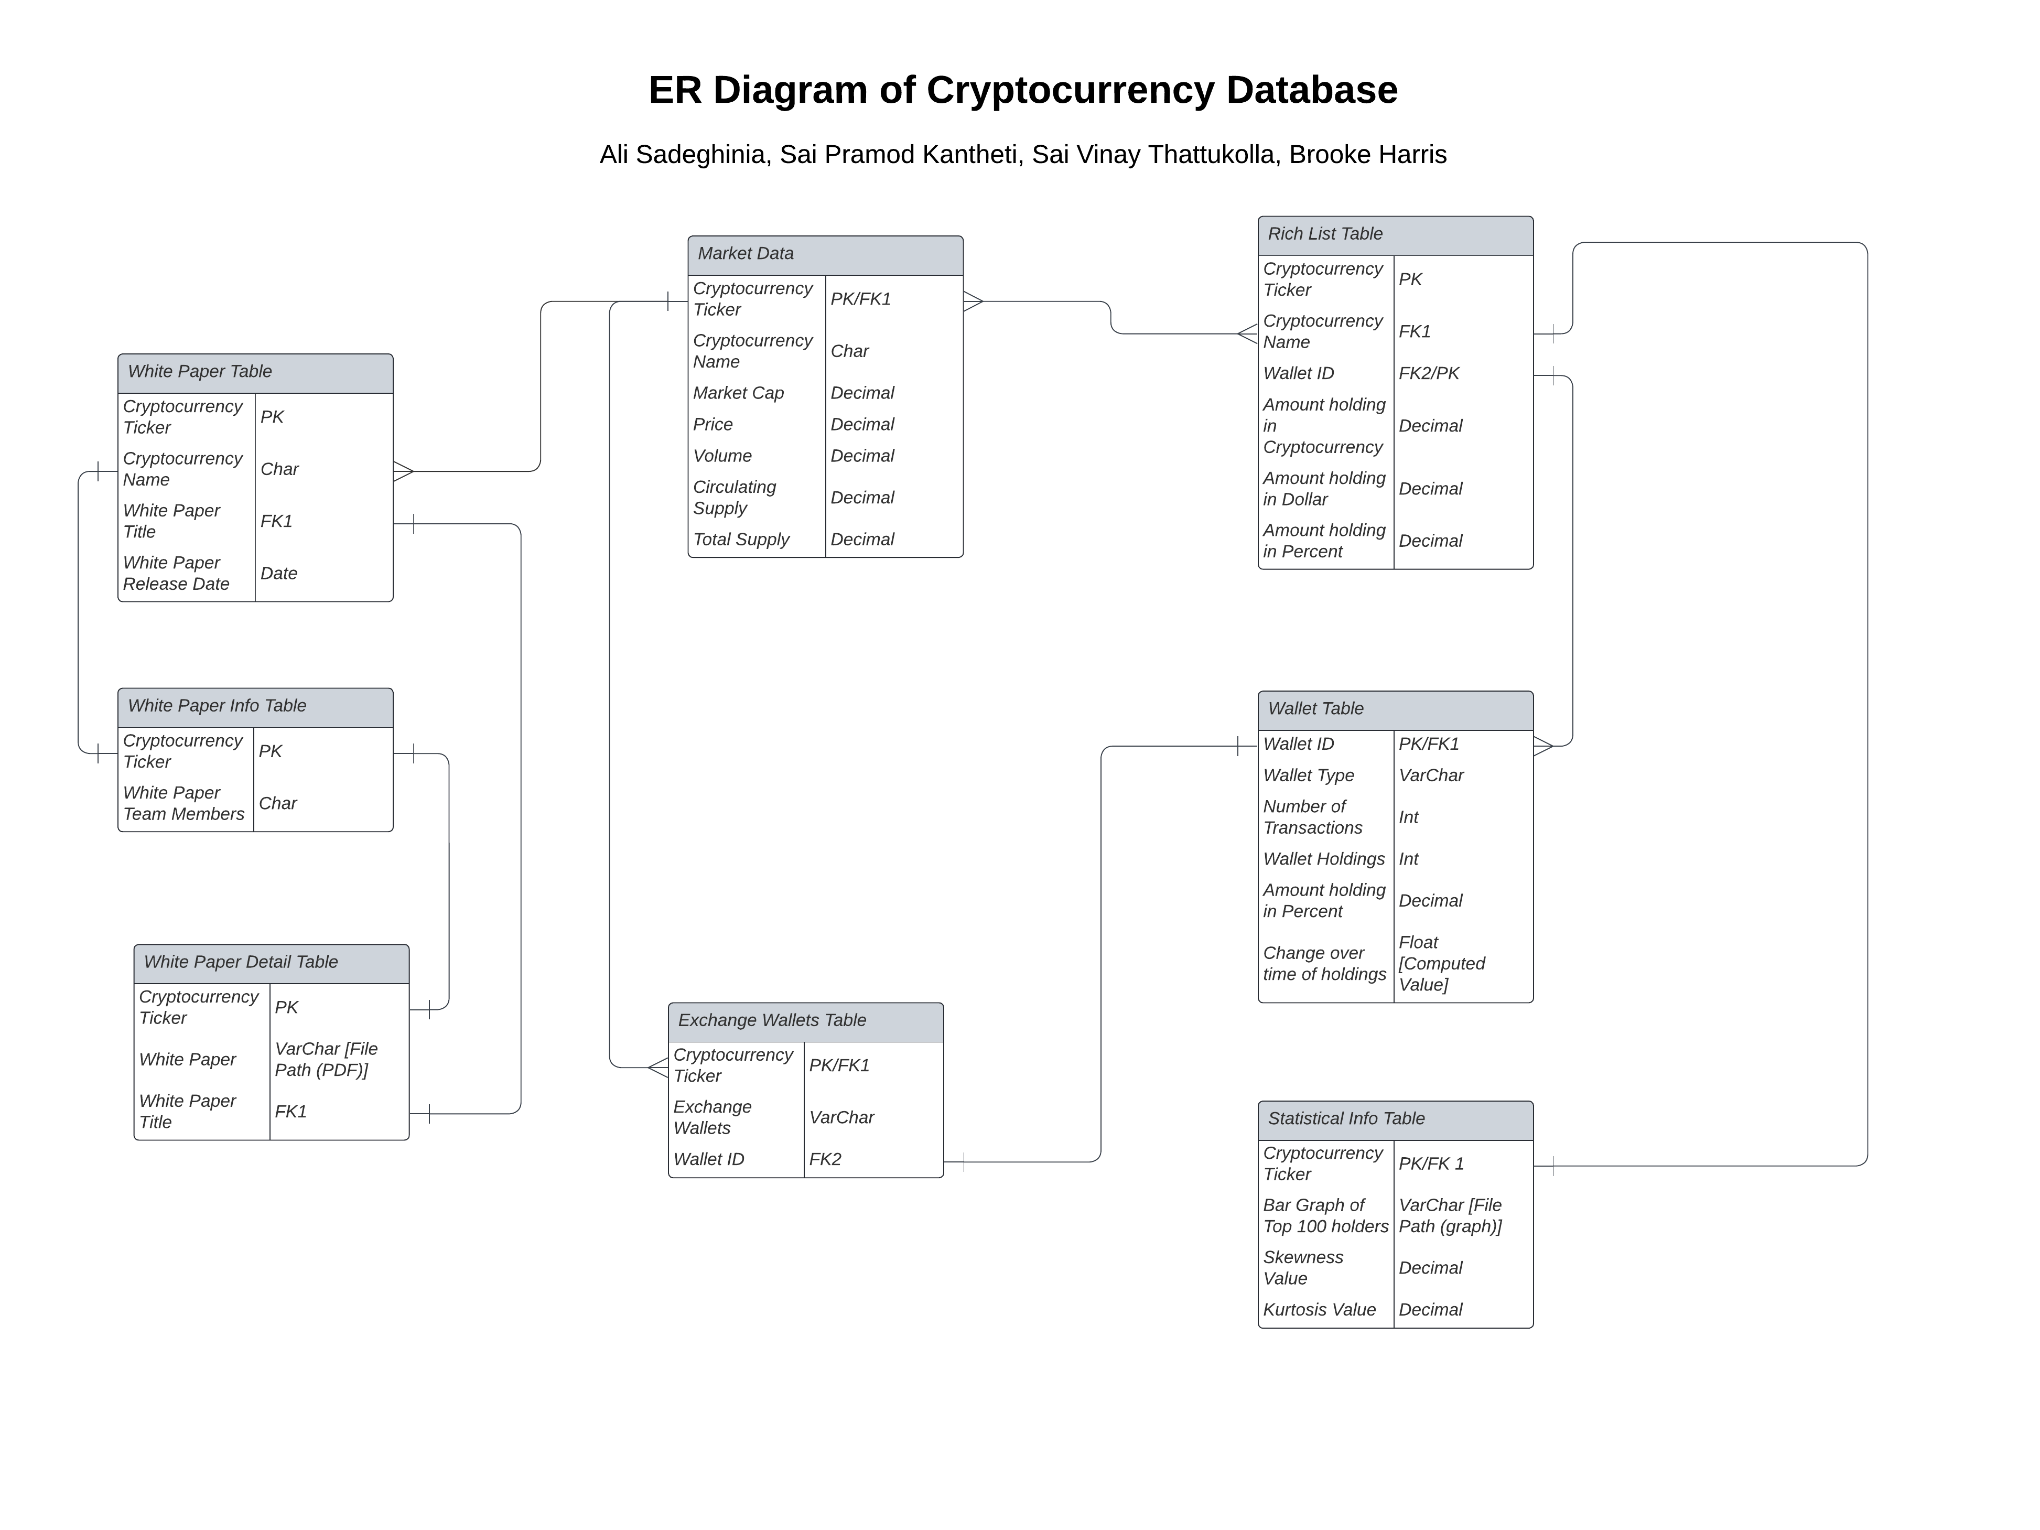

**The project will be completed in 4 phases:**

**Phase 0:** Discuss the project and what the database will look like, what kinds of data it will contain, what would be the purpose of the database, etc.

Deadline: 03/20/2023 Finished: 03/20/2023

Phase 1: Collecting and cleaning the data, which requires scraping, statistical analysis, and manually collecting the data.

Deadline: 04/02/2023 Finished:

Phase 2: Create the relational database regarding the ER Diagram above (or any updated version after Phase 1).

Deadline: 04/08/2023 Finished:

Phase 3: Create an interactive website for the database using CSS and HTML.

Deadline: 04/23/2023 Finished:

All members will be contributing to all phases of the project.

**Group Members:**

1. Ali Sadeghinia
2. Brooke Harris
3. Sai Pramod Kantheti
4. Sai Vinay Thattukolla